Manorath Ital D20A

Blockchain Experiment 11

AIM: To implement a Hyperledger Fabric network, deploy chaincode, and perform asset creation, querying, and transfer operations.

PROCEDURE

Step 1: Update the system
Go to https://shell.cloud.google.com and run the following commands:
sudo apt update sudo apt upgrade -y

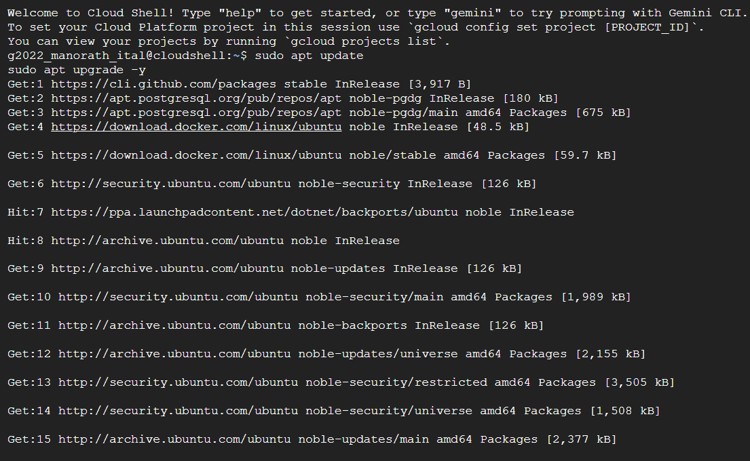

Step 2: Install Required Dependencies

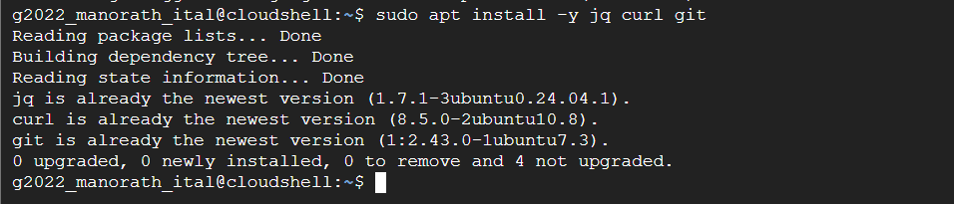

Then verify everything is present:
node -v npm -v
git --version docker --version docker ps
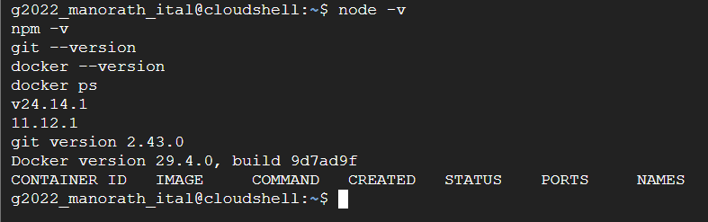

Step 3: Fix Docker Compose
DOCKER_CONFIG=${DOCKER_CONFIG:-$HOME/.docker}
mkdir -p $DOCKER_CONFIG/cli-plugins curl -SL
https://github.com/docker/compose/releases/download/v2.24.5/docker-compose
-linux-x86_64 \
-o $DOCKER_CONFIG/cli-plugins/docker-compose chmod +x $DOCKER_CONFIG/cli-plugins/docker-compose docker compose version
sudo mv /usr/bin/docker-compose /usr/bin/docker-compose-old 2>/dev/null || true
sudo tee /usr/local/bin/docker-compose > /dev/null <<'EOF' #!/bin/bash
exec docker compose "$@" EOF
sudo chmod +x /usr/local/bin/docker-compose docker compose version

docker-compose version
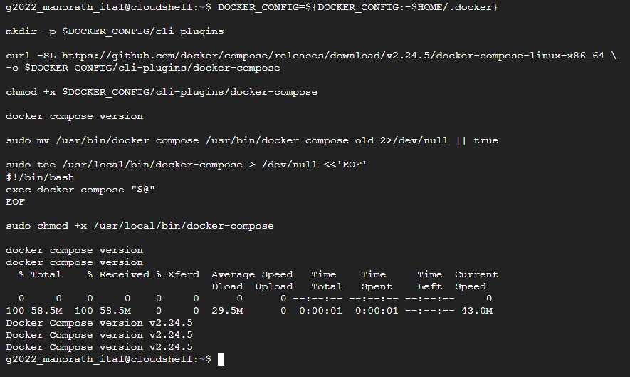

Step 4: Clone Fabric Samples
cd $HOME
git clone https://github.com/hyperledger/fabric-samples cd fabric-samples
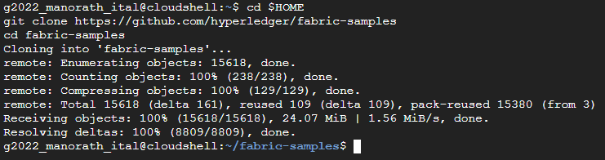

Step 5: Install Fabric Binaries and Docker Images
curl -sSLO https://raw.githubusercontent.com/hyperledger/fabric/main/scripts/install- fabric.sh
chmod +x install-fabric.sh
./install-fabric.sh docker samples binary

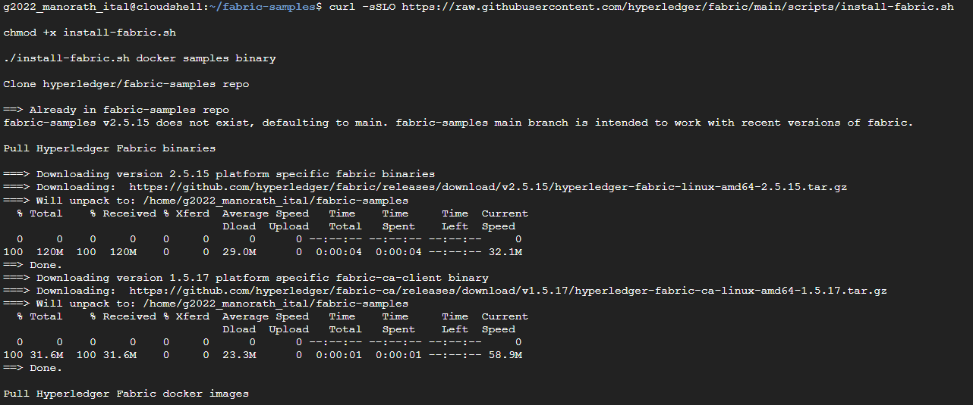
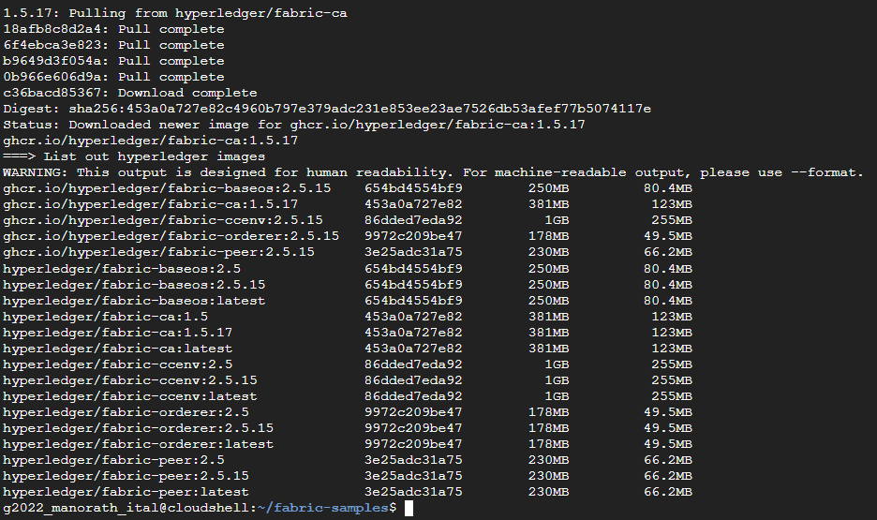

Step 6: Verify Docker images
docker images | grep fabric
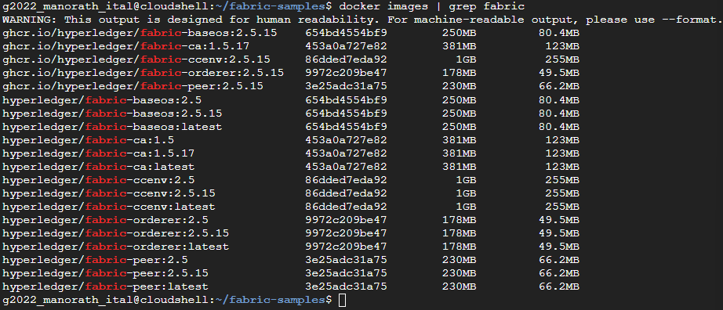

Step 7: Set Environment Variables
export PATH=$PATH:$HOME/fabric-samples/bin
export FABRIC_CFG_PATH=$HOME/fabric-samples/config peer version

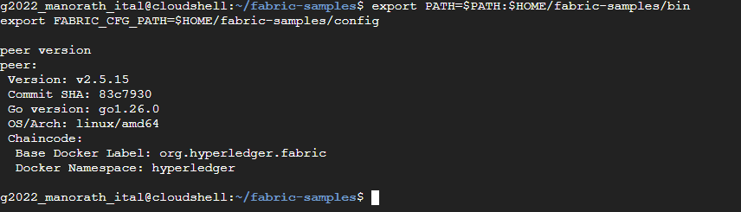

Step 8: Start the Network and Create Channel
cd $HOME/fabric-samples/test-network
./network.sh up createChannel

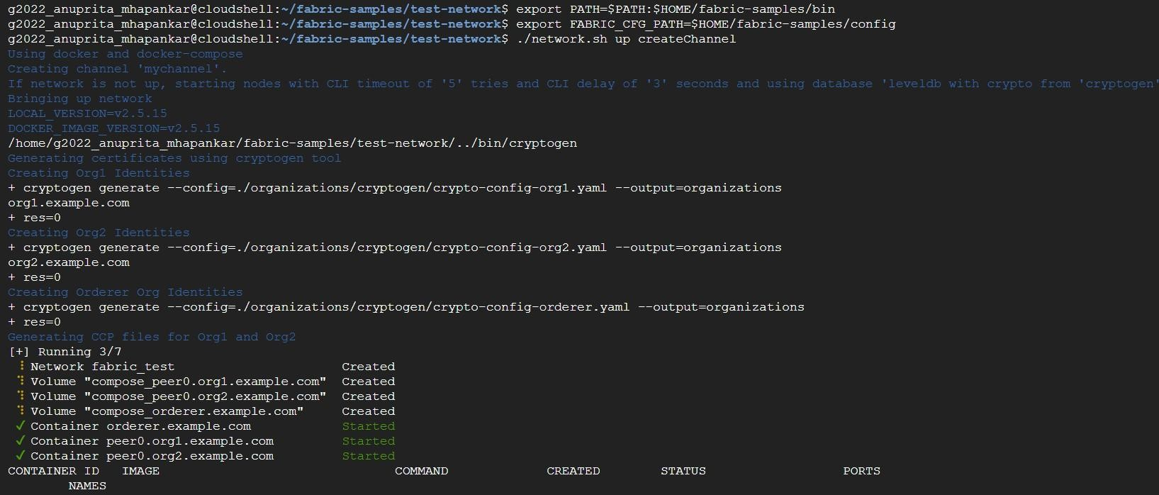
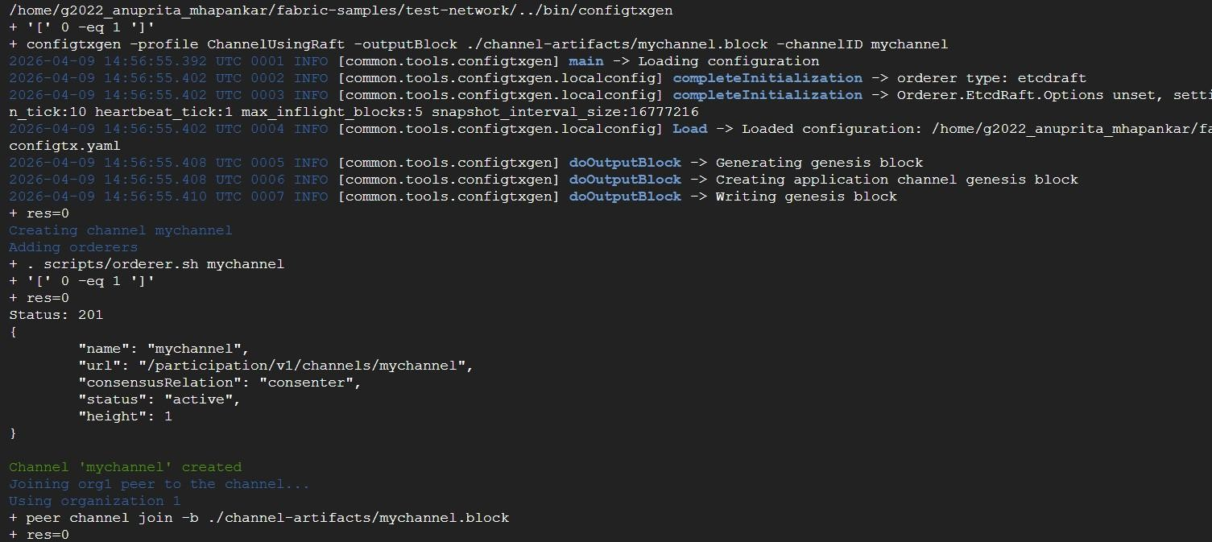
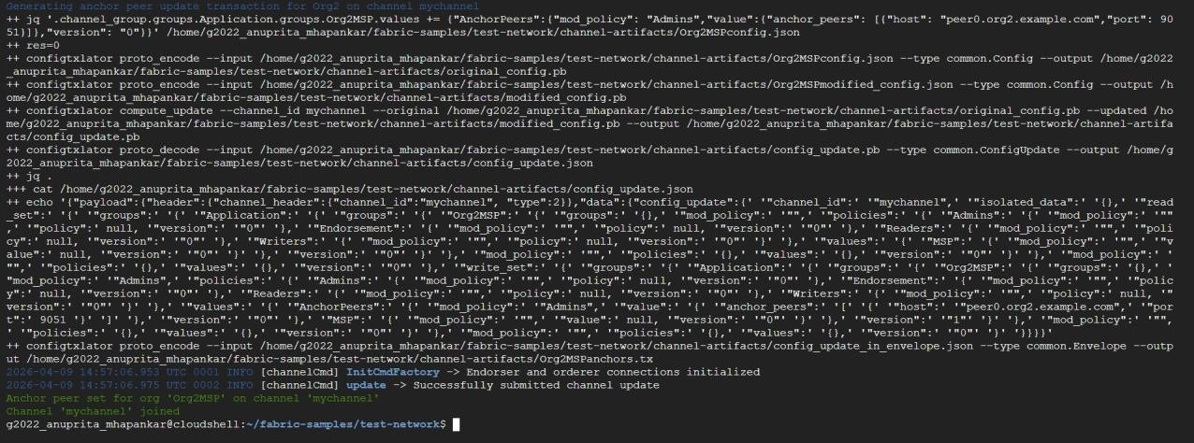

Step 9: Deploy Chaincode
./network.sh deployCC \
-ccn basic \
-ccp ../asset-transfer-basic/chaincode-javascript \
-ccl javascript
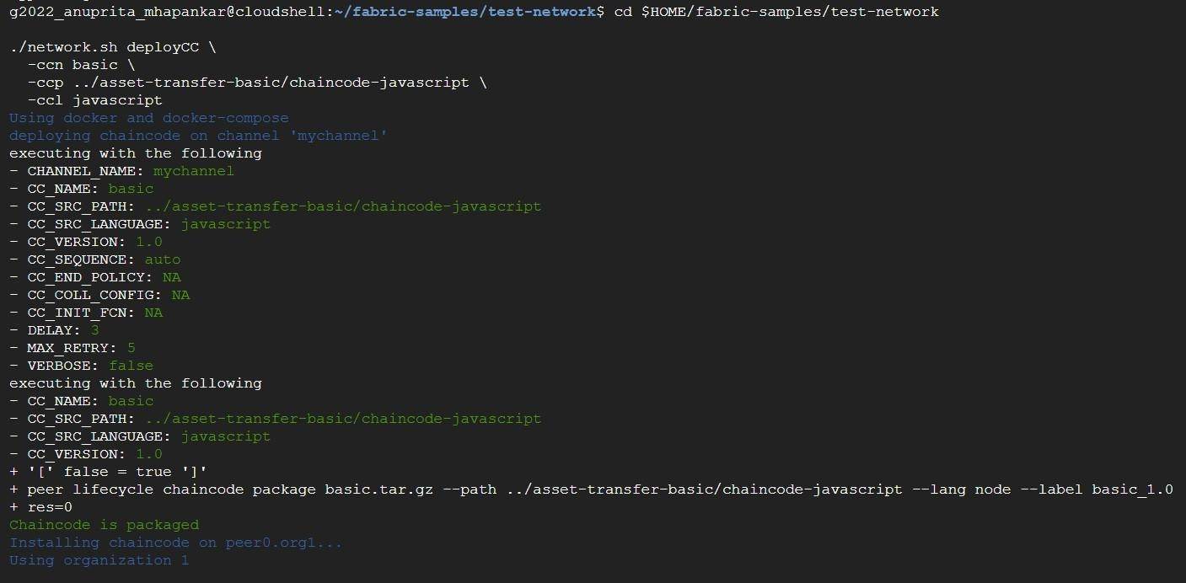
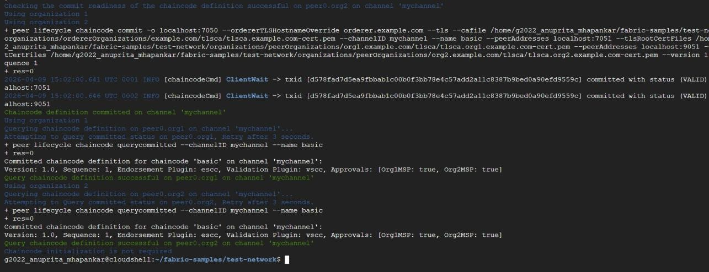

Step 10: Set Peer Environment Variables
export FABRIC_CFG_PATH=$HOME/fabric-samples/config export PATH=$PATH:$HOME/fabric-samples/bin
export CORE_PEER_TLS_ENABLED=true export CORE_PEER_LOCALMSPID="Org1MSP"
export
CORE_PEER_TLS_ROOTCERT_FILE=$HOME/fabric-samples/test-network/organization s/peerOrganizations/org1.example.com/peers/peer0.org1.example.com/tls/ca.c rt

export
CORE_PEER_MSPCONFIGPATH=$HOME/fabric-samples/test-network/organizations/pe erOrganizations/org1.example.com/users/Admin@org1.example.com/msp
export CORE_PEER_ADDRESS=localhost:7051
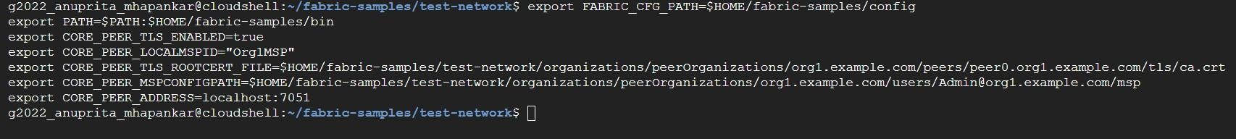

Step 11: Initialize Ledger
peer chaincode invoke \
-o localhost:7050 \
--ordererTLSHostnameOverride orderer.example.com \
--tls \
--cafile
$HOME/fabric-samples/test-network/organizations/ordererOrganizations/examp le.com/orderers/orderer.example.com/msp/tlscacerts/tlsca.example.com-cert. pem \
-C mychannel \
-n basic \
--peerAddresses localhost:7051 \
--tlsRootCertFiles
$HOME/fabric-samples/test-network/organizations/peerOrganizations/org1.exa mple.com/peers/peer0.org1.example.com/tls/ca.crt \
--peerAddresses localhost:9051 \
--tlsRootCertFiles
$HOME/fabric-samples/test-network/organizations/peerOrganizations/org2.exa mple.com/peers/peer0.org2.example.com/tls/ca.crt \
-c '{"function":"InitLedger","Args":[]}'
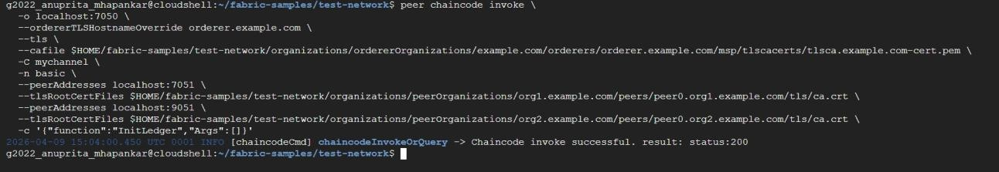

Step 12: Query All Assets
peer chaincode query -C mychannel -n basic -c '{"Args":["GetAllAssets"]}'

Step 13: Read a Specific Asset
peer chaincode query -C mychannel -n basic -c '{"Args":["ReadAsset","asset5"]}'

Step 14: Create a New Asset
peer chaincode invoke \
-o localhost:7050 \
--ordererTLSHostnameOverride orderer.example.com \
--tls \
--cafile
$HOME/fabric-samples/test-network/organizations/ordererOrganizations/examp le.com/orderers/orderer.example.com/msp/tlscacerts/tlsca.example.com-cert. pem \
-C mychannel \
-n basic \
--peerAddresses localhost:7051 \
--tlsRootCertFiles
$HOME/fabric-samples/test-network/organizations/peerOrganizations/org1.exa mple.com/peers/peer0.org1.example.com/tls/ca.crt \
--peerAddresses localhost:9051 \
--tlsRootCertFiles
$HOME/fabric-samples/test-network/organizations/peerOrganizations/org2.exa mple.com/peers/peer0.org2.example.com/tls/ca.crt \
-c '{"function":"CreateAsset","Args":["asset7","blue","10","Anuprita","500"]} '
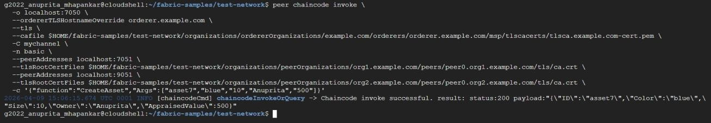

Step 15: Transfer Asset
peer chaincode invoke \
-o localhost:7050 \
--ordererTLSHostnameOverride orderer.example.com \
--tls \
--cafile
$HOME/fabric-samples/test-network/organizations/ordererOrganizations/examp le.com/orderers/orderer.example.com/msp/tlscacerts/tlsca.example.com-cert. pem \
-C mychannel \
-n basic \
--peerAddresses localhost:7051 \
--tlsRootCertFiles
$HOME/fabric-samples/test-network/organizations/peerOrganizations/org1.exa mple.com/peers/peer0.org1.example.com/tls/ca.crt \

--peerAddresses localhost:9051 \
--tlsRootCertFiles
$HOME/fabric-samples/test-network/organizations/peerOrganizations/org2.exa mple.com/peers/peer0.org2.example.com/tls/ca.crt \
-c '{"function":"TransferAsset","Args":["asset7","Sneha"]}'
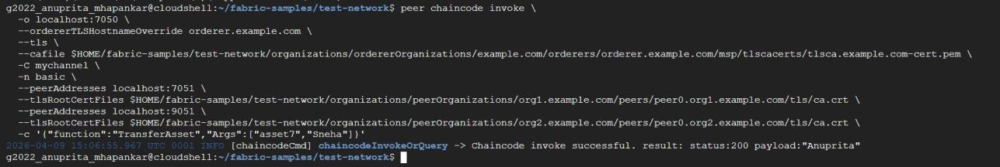

Step 16: Stop the Network
cd $HOME/fabric-samples/test-network
./network.sh down
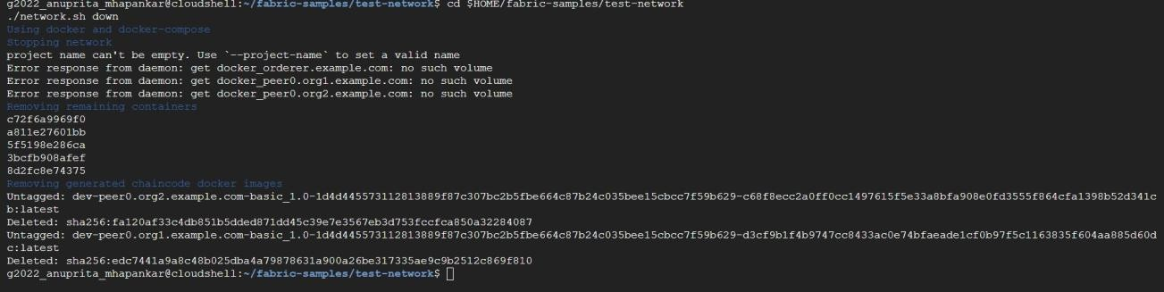

CONCLUSION:

The Hyperledger Fabric network was successfully implemented and chaincode was deployed. Asset operations such as creation, querying, and transfer were performed successfully. This experiment demonstrated secure and efficient asset management using a permissioned blockchain system.

